Geometry: Unit 3, Lesson 7
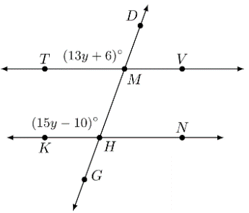
- Lines $TV$, $KN$, and $DG$ are shown. $\overset{⃡}{TV}∥\overset{⃡}{KN}$ with traversal $\overset{⃡}{DG}$. $m∠DMT=\left(13y+6\right)°$, $m∠TMH=70°$, and $m∠KHM=\left(15y-10\right)°$. What is an equation that can be used to find the value of $y$?

$$\left(13y+6\right)=(15y-10)$$

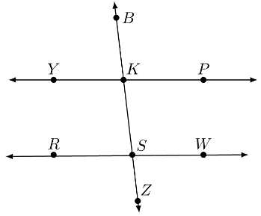
- Lines $YP$, $RW$, and $BZ$ are shown, where $\overset{⃡}{YP}∥\overset{⃡}{RW}$ and $\overset{⃡}{BZ}$ is the traversal. $m∠BKP=\left(18m-2\right)°$ and $m∠WSZ=\left(22m-38\right)°$. What type of angles are $∠BKP$ and $∠WSZ$?

Consecutive exterior angles

- Given the equation $9t-12.75=8.5t+4$, what is the value of $t$?

$$33.5$$

